**MiniiProjectiReportion**



**FACEiDETECTION**



**Submittediinipartialifulfillmentiofitheirequirementiforitheiawardiofitheidegreeiof**

**BACHELORiOFiTECHNOLOGY**

**IN**

**COMPUTERiSCIENCEi&iENGINEERINGi**

**(CSEiIIIiSemesteriMiniiprojectiPCS-301)**

**2022-2023**

**iiSubmittediby:**

**StudentiNamei–iAnkitiPundiriiiiiiiiiiiiiiiiiiUniversityiRolliNo.i2018686**

***UnderitheiMentorshipiof***

**MriSaurabhiKumariMishra**

**AssistantiProfessor**



**DepartmentiofiComputeriScienceiandiEngineering**

**GraphiciErai(DeemeditoibeiUniversity)**

**Dehradun,iUttarakhand**

**Januaryi2023**



iiiiiiiiiiiiiiiiiii

**CANDIDATE’SiDECLARATION**

Iiherebyicertifyithatitheiworkiwhichiisibeingipresentediinitheiprojectireportientitled**i“FaceiDetection”**iinipartialifulfillmentiofitheirequirementsiforitheiawardiofitheiDegreeiofiBacheloriofiTechnologyiiniComputeriScienceiandiEngineering**i**ofitheiGraphiciErai(DeemeditoibeiUniversity),iDehradunishallibeicarriedioutibyitheiunderitheimentorshipiofi**MriSaurabhiKumariMishra,iAssistantiProfessor**,iDepartmentiofiComputeriScienceiandiEngineering,iGraphiciErai(DeemeditoibeiUniversity),iDehradun.

Nameiii-iAnkitiPundiri UniversityiRollinoi-iii2018686 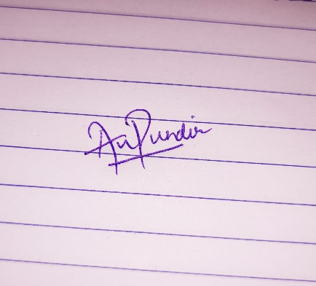

**TABLEiOFiCONTENTS**

**CHAPTERiNO.i TITLEi iiiiiiPAGEiNO.**

**1. iINTRODUCTION 5-6**

1.1i AboutiProject 5

1.2i Pythoni 5

1.3 PythoniLibraries 5

1.3.1 iCV2 5

1.3.2 iHaariCascade 6

1.3.3 iCascadeiClassifier 6

**2.ii LITERATUREiSURVEY iiiiiiiiii7-9**

2.1 History 7

2.2 TraditionaliTechniques 7-8

2.3 Applications 8

2.4 ChallengesiandiFutureiResearchiDirections 9

**3. METHODOLOGY iiiiii10-11**

3.1 MethodiandiClassifier i10

3.1.1 Pre-processingiStep: iiiiiiiiiii10

3.1.2 LoadingiClassifier iiiiiiiiiii10

3.1.3iiiDrawingiofiRectangle iiiiiiiiiii11

3.1.4iiiDisplayiImage iiiiiiiiiii11

3.2 ShortiOverview

**4. RESULTiANDiDISCUSSIONS iiiiii12-13**

**5. CONCLUSIONiANDiFUTUREiWORK iiiiii14-15**

5.1 Conclusion i14

5.2 FutureiWork iiiiii14-15

References i16

**CHAPTER**i**1**

**INTRODUCTION**

* 1. **ABOUTiPROJECT**

Aifaceirecognitioniattendanceisystemiisiaitechnologyicapableiofimatchingiaihumanifaceifromiaidigitaliimageioriaivideoiframeiagainstiaidatabaseiofifaces,itypicallyiemployeditoiauthenticateiusersithroughiIDiverificationiservices,iworksibyipinpointingiandimeasuringifacialifeaturesifromiaigiveniimage.

Aifaceirecognitioniattendanceisystemiusesibiometricsitoimapifacialifeaturesifromiaiphotographiorivideo.iIticomparesitheiinformationiwithiaidatabaseiofiknownifacesitoifindiaimatch.iFacialirecognitionicanihelpiverifyiaiperson'siidentity,ibutiitialsoiraisesiprivacyiissues.

**1.2i PYTHON**

Pythoniisianiinterpretedihigh-leveligeneral-purposeiprogrammingilanguage.iItsidesigniphilosophyiemphasizesicodeireadabilityiwithiitsiuseiofisignificantiindentation.iItsilanguageiconstructsiasiwelliasiitsiobject-orientediapproachiaimitoihelpiprogrammersiwriteiclear,ilogicalicodeiforismalliandilarge-scaleiprojects.

**1.3i PYTHONiLIBRARIES**

PythoniLibrariesiareiaisetiofiusefulifunctionsithatieliminateitheineediforiwritingicodesifromiscratch.iThereiareioveri137,000ipythonilibrariesipresentitoday.iPythonilibrariesiplayiaivitaliroleiinidevelopingimachineilearning,idataiscience,idataivisualization,iimageiandidataimanipulationiapplications,iandimore.

**1.3.1i CV2**

CV2iisitheimoduleiimportinameiforiopencv-python,i"Unofficialipre-builtiCPU-onlyiOpenCVipackagesiforiPython".iTheitraditionaliOpenCVihasimanyicomplicatedistepsiinvolvingibuildingitheimoduleifromiscratch,iwhichiisiunnecessary.iIiwouldirecommendiremainingiwithitheiopencv-pythonilibrary.

**1.3.2 HaariCascade**

AiHaariCascadeiisiaiclassifieriwhichiisitraineditoidetectifeaturesiiniimages.iIt'siusediiniobjectidetectionitasks,isuchiasifaceidetection,iandiisiparticularlyieffectiveibecauseiiticanibeitraineditoidetectifeaturesiatidifferentiscales,iallowingiititoifindiobjectsiiniimagesiregardlessiofitheirisize.iTheiHaariCascadeialgorithmiworksibyitrainingiaiclassifierioniaisetiofipositiveiandinegativeiimages,ianditheniusingithaticlassifieritoidetectiobjectsiininewiimages.iHaaricascadesiareiparticularlyipopulariforifaceidetectionibecauseitheyiareiableitoidetectifacesiwithihighiaccuracy,ieveniwhenitheifaceiisipartiallyiobscuredioriiniprofile.

**1.3.3 CascadeiClassifier**

Aicascadeiclassifieriisiaimachineilearning-baseditechniqueithatiisicommonlyiusediiniobjectidetectionitasks,iincludingifaceirecognition.iItiisiaitypeiofiensembleiclassifierithatiisimadeiupiofimultipleistages,ieachiofiwhichiincludesiaiweakiclassifier.iTheicascadeiclassifieriworksibyiapplyingieachiweakiclassifieriinisequenceitoianiimage,iandiifitheiimageiisirejectedibyianyiofitheiclassifiers,iitiisinoticonsidereditoicontainitheiobjectiofiinteresti(e.g.,iaiface).

Iniaifaceirecognitioniproject,iaicascadeiclassifieriisitrainedioniaisetiofipositiveiandinegativeiimagesiofifaces,ianditheniuseditoidetectifacesiininewiimages.iOnceitheifacesiareidetected,itheyiareitypicallyialignediandinormalizeditoiaistandardisizeiandiposition,ianditheniaifeatureiextractoriisiapplieditoiextractiaisetiofifacialifeatures.iTheseifeaturesiareitheniuseditoitrainiaiclassifieritoirecognizeispecificiindividuals.

**CHAPTER**i**2**

**LITERATUREiSURVEY**

**2.1i History:i-**

Theihistoryiofifaceidetectionicanibeitracedibackitoitheiearlyi20thicentury,iwithitheiearliestiknowniresearchionitheitopiciappearingiinithei1920s.iEarlyifaceidetectionimethodsiwereibasedionisimpleigeometriciandiphotometricifeatures,isuchiasitheidistancesibetweenikeyipointsionitheifaceiandiwereinotiveryiaccurate.

Inithei1980s,iresearchersibeganitoidevelopimoreisophisticatedimethodsiforifaceidetection,isuchiasitheieigenfaceimethod,iwhichiusediprincipalicomponentianalysisi(PCA)itoirepresentifacesiasiaisetiofieigenvectors.iHowever,itheseimethodsiwereistillinotiveryiaccurateiandiwereilimitediinitheiriabilityitoihandleivariationsiinilightingiandipose.

Initheiearlyi2000s,iViolaiandiJonesiproposediaireal-timeifaceidetectionimethodibasedioniHaaricascades,iwhichiusediaisetiofisimpleifeaturesitoiclassifyiregionsiofianiimageiasieitherifaceiorinon-face.iThisimethodiwasiaisignificantiimprovementioveripreviousimethodsiandiisistilliwidelyiuseditodayiinimanyiapplications.

Withitheiadventiofideepilearningiandiconvolutionalineuralinetworksi(CNNs)iinithei2010s,ifaceidetectionihasiseeniaimajoribreakthrough.iTheidevelopmentiofiCNN-basedimethods,isuchiasiFaceNetiandiRetinaFace,ihasileditoiaisignificantiimprovementiinitheiaccuracyiandirobustnessiofifaceidetectionimethods.

Today,ifaceidetectionitechniquesicontinueitoiimproveiwithitheihelpiofideepilearningitechniques,iandiresearchersiareiworkingionimakingiitimoreiaccurate,irobust,iandiefficient.

Top of Form

**2.2i Traditionalitechniques:i-**

Haaricascades:iHaaricascades,iproposedibyiViolaiandiJonesiini2001,iisioneiofitheimostiwidelyiuseditraditionalimethodsiforifaceidetection.iItiisibasedionitheiideaiofiusingiaisetiofisimpleifeaturesicallediHaar-likeifeaturesitoiclassifyiregionsiofianiimageiasieitherifaceiorinon-face.iTheimethodiusesiaicascadeioficlassifiers,iwhereieachiclassifieriisitraineditoidetectiaispecificifeatureiofitheiface,isuchiasitheieyesiorinose.iHaaricascadesiareiefficientiandicaniruniinireal-time,ibutitheyicanihaveidifficultyidetectingifacesiwithilargeivariationsiinilightingiandipose.

Viola-Jones:iViola-Jonesiisiaireal-timeifaceidetectionimethodiproposedibyiViolaiandiJonesiini2001.iItiisibasedionitheiuseiofiHaar-likeifeatures,iwhichiareisimpleirectangularifeaturesicomputedifromitheiimageipixels.iTheimethodiusesianiAdaBoostialgorithmitoitrainiaicascadeioficlassifiers,iwhereieachiclassifieriisitraineditoidetectiaispecificifeatureiofitheiface,isuchiasitheieyesiorinose.iViola-Jonesiisiefficientiandicaniruniinireal-time,ibutiiticanihaveidifficultyidetectingifacesiwithilargeivariationsiinilightingiandipose.

HOG+SVM:iHistogramsiofiorientedigradientsi(HOG)iandisupportivectorimachinesi(SVM)iisiaifaceidetectionimethodithaticombinesitheiuseiofiHOGifeaturesiandiSVMiclassifiers.iHOGifeaturesiareiuseditoicaptureitheishapeianditextureiofitheiface,iwhileiSVMiclassifiersiareiuseditoiclassifyiregionsiofitheiimageiasieitherifaceiorinon-face.iThisimethodiisimoreirobustitoivariationsiinilightingiandiposeithaniHaaricascades,ibutiitiisilessiefficientiandimayinotibeisuitableiforireal-timeiapplications.

Allitheseitraditionalitechniquesirelyionihandcraftedifeaturesianditheiriperformanceimayinotibeiasigoodiasideepilearning-basedimethods,iiniparticulariwhenidealingiwithilargeivariationsiofilighting,ipose,iandiocclusions.

**2.3 Applications:i-**

Faceidetectionihasiaiwideirangeiofiapplications,iincluding:

1. Securityisystems:iFaceidetectioniisicommonlyiusediinisecurityisystemsitoiidentifyiandiauthenticateiindividuals.iItiisiusediiniaccessicontrolisystems,isuchiasiinibuildingsiandiairports,itoiverifyitheiidentityiofiindividualsibeforeigrantingithemiaccess.
2. Biometrics:iFaceidetectioniisiusediinibiometricisystemsitoiidentifyiandiauthenticateiindividualsibasedionitheiriuniqueifacialifeatures.iItiisiusediiniaivarietyiofiapplications,isuchiasipassporticontrol,icriminaliidentification,iandipersonaliidentification.
3. Videoisurveillance:iFaceidetectioniisiusediinivideoisurveillanceisystemsitoiautomaticallyidetectianditrackiindividualsiinireal-time.iItiisiuseditoimonitoripublicispaces,isuchiasiairports,imalls,ianditrainistations,itoidetectisuspiciousibehaviouriandiidentifyipotentialisecurityithreats.
4. RoboticsiandiHuman-computeriinteraction:iFaceidetectioniisiusediiniroboticsiandihuman-computeriinteractionitoienableirobotsitoirecognizeiandiinteractiwithipeople.iItiisiusediiniapplicationsisuchiasisocialirobots,iassistiveirobots,iandiautonomousivehicles.
5. Entertainment:iFaceidetectioniisialsoiusediinientertainment,isuchiasivideoigamesiandiaugmentedirealityiapplications.
6. SocialiMedia:iFaceidetectioniisiofteniuseditoiautomaticallyitagipeopleiiniphotosiandivideosionisocialimediaiplatforms,imakingiitieasieriforiusersitoiorganizeiandishareitheiricontent.
7. Marketing:iFaceidetectionitechnologyiisialsoiusediinimarketing,itoiidentifyianditrackicustomersiinireal-time,iprovidingivaluableiinsightsiintoiconsumeribehaviouriandipreferences.

**2.4iiiii****ChallengesiandiFutureiResearchiDirections:i-**

* Currentichallengesiandilimitationsiofifaceidetectionimethodsiinclude:

1. Variationsiinilightingiandipose:iFaceidetectionimethodsicanihaveidifficultyidetectingifacesiwithilargeivariationsiinilightingiandipose,iasitheseivariationsicaniaffectitheiappearanceiofitheifaceiandimakeiitidifficultiforitheialgorithmitoirecognize.
2. Occlusions:iFaceidetectionimethodsicanihaveidifficultyidetectingifacesithatiareipartiallyioccluded,isuchiasibyiglassesiorihats.
3. Lowiresolution:iFaceidetectionimethodsicanihaveidifficultyidetectingifacesiinilowiresolutioniimagesiorivideos,iasitheifacialifeaturesimayinotibeiclearlyivisible.
4. Adversarialiexamples:iWithitheiincreasingiuseiofideepilearningiinifaceidetection,iadversarialiexamples,iwhichiareiimagesispecificallyidesigneditoifoolitheimodel,ibecomeiaiconcern.
5. Privacyiandiethicaliconsiderations:iWithitheiincreasingiuseiofifaceidetectioniinisurveillanceiandibiometricisystems,iprivacyiandiethicaliconsiderationsibecomeiaiconcern.

* Potentialifutureiresearchidirectionsiforifaceidetectioniinclude:

1. Developingimoreirobustifaceidetectionimethodsithaticanihandleilargeivariationsiinilightingiandipose,iasiwelliasiocclusions.
2. Developingifaceidetectionimethodsithatiareimoreiefficientiandicaniruniinireal-timeionimobileiandiembeddedidevices.
3. Developingimethodsiforihandlingilowiresolutioniimagesiandivideos.
4. Developingimethodsiforidetectingiandimitigatingitheieffectsiofiadversarialiexamples.
5. Researchingitheiethicaliandiprivacyiimplicationsiofifaceidetectionitechnologyiandidevelopingimethodsiforiprotectingitheiprivacyiofiindividuals.
6. Incorporatingimoreirobustirepresentationsiandiarchitecturesitoiimproveitheirobustnessiofitheimodelsitoivariationsiinipose,ilighting,iandiocclusion.
7. DevelopingimoreiadvanceditechniquesisuchiasiGenerativeiAdversarialiNetworksi(GANs)ioriVariationaliAutoencoderi(VAE)iforifaceidetection.
8. Incorporatingiactiveilearningitechniquesitoiimproveitheiperformanceiofifaceidetectionimodelsibyiselectingitheimostiinformativeisamplesiforiannotation.

**CHAPTER**i**3**

**METHODOLOGY**

**3.1** **MethodiandiClassifier:i-**

TheifaceidetectionimethodiusediinitheiprovidedicodeiisitheiViola-Jonesimethod,iwhichiisianialgorithmiforidetectingifacesiiniimages.iThisimethodiusesiaiclassifiericallediaicascadeiclassifier,iwhichiisitraineditoidetectifacesiiniimagesibyilookingiforispecificifeaturesisuchiasiedgesianditextures.

**3.1.1iiiPre-processingiStep:i-**

Theifirstipre-processingistepiinitheicodeiisiconvertingitheiimageitoigrayscale.iThisiisidoneibecauseitheiViola-Jonesimethodiworksibestionigrayscaleiimagesiandiitiisimoreiefficientitoiprocessigrayscaleiimagesithanicoloriimages.

**3.1.2iiiLoadingiClassifier:i-**

Theinextistepiisiloadingiaipre-trainedicascadeiclassifiericalledi'Face.xml'ithatiisitraineditoidetectifaces.iThisiclassifieriisitheniuseditoidetectifacesiinitheigrayscaleiimageibyicallingitheidetectMultiScaleimethod.iThisimethoditakesitheigrayscaleiimageiasiinputiandireturnsianiarrayioficoordinatesiforieachifaceidetectediinitheiimage.

**3.1.3iiiDrawingiofiRectangle:i-**

Theiforiloopiisitheniuseditoiiterateioveritheicoordinatesiofieachifaceidetected.iForieachisetioficoordinates,itheiloopiisidrawingiairectangleiarounditheidetectedifaceiusingitheirectangleifunctionifromiOpenCV.iThisifunctionitakesitheioriginaliimage,itheicoordinatesiofitheitop-lefticornerianditheibottom-righticorneriofitheirectangle,ianditheicoloriandithicknessiofitheirectangleiasiinput.

**3.1.4iiiDisplayiImage:i-**

Finally,itheicodeiisiresizingitheiimage,idisplayingiitionitheiscreen,iandipausingitheiexecutioniofitheiprogramiuntiliaikeyiisipressed.

**3.2 ShortiOverview:i-**

Inishort,itheicodeiisiusingitheiViola-Jonesimethodiwithiaipre-trainedicascadeiclassifieritoidetectimultipleifacesiinianiimage.iIticonvertsitheiimageitoigrayscale,iloadsitheiclassifier,idetectsifacesiinitheiimageiusingitheidetectMultiScaleimethod,iandithenidrawsirectanglesiarounditheidetectedifacesiusingiaiforiloop.

Top of Form

**CHAPTER**i**4**

**ResultiandiDiscussion**

Theiresultsiofirunningitheiaboveicodeionitheisampleiimageiwouldiinclude:

1. Theioriginaliimage.
2. Theigrayscaleiversioniofitheiimage,iwhichiisiusediasiinputiforitheifaceidetectionialgorithm.
3. Theifinaliimageiwithirectanglesidrawniarounditheidetectedifaces.
4. TheioutputifromitheifaceCoordinatesivariable,iwhichishowsitheicoordinatesiofitheidetectedifacesiinitheiimage.

Itishouldibeinotedithatitheiresultsiwillidependionitheiqualityiandiresolutioniofitheiimageiused,iasiwelliasitheiaccuracyiofitheipre-trainediclassifieriusediinitheicode.iTheiperformanceiofitheialgorithmicanibeievaluatedibyicomparingitheinumberiofifacesidetectedibyitheialgorithmitoitheinumberiofiactualifacesipresentiinitheiimage.

Top of Form

Top of Form

Top of Form

**ImageicontainingiuniqueifaceiDetectedi:i-**

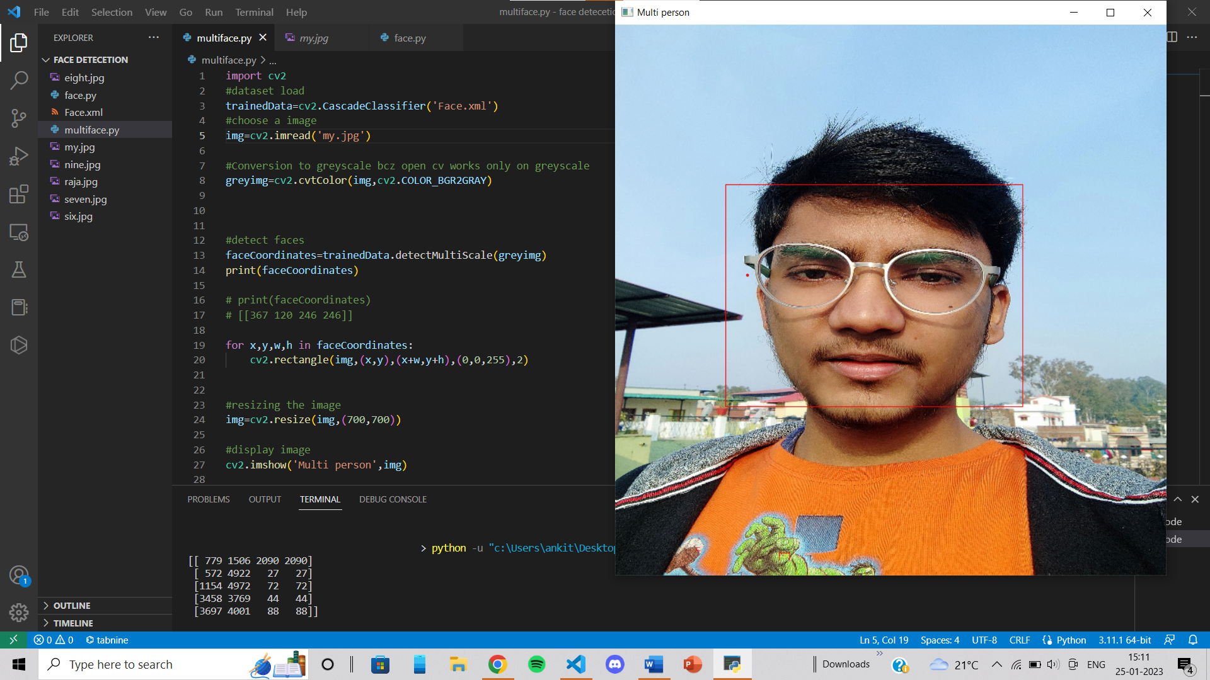

**ImageiDetectediwithimultipleifacesi:i-**

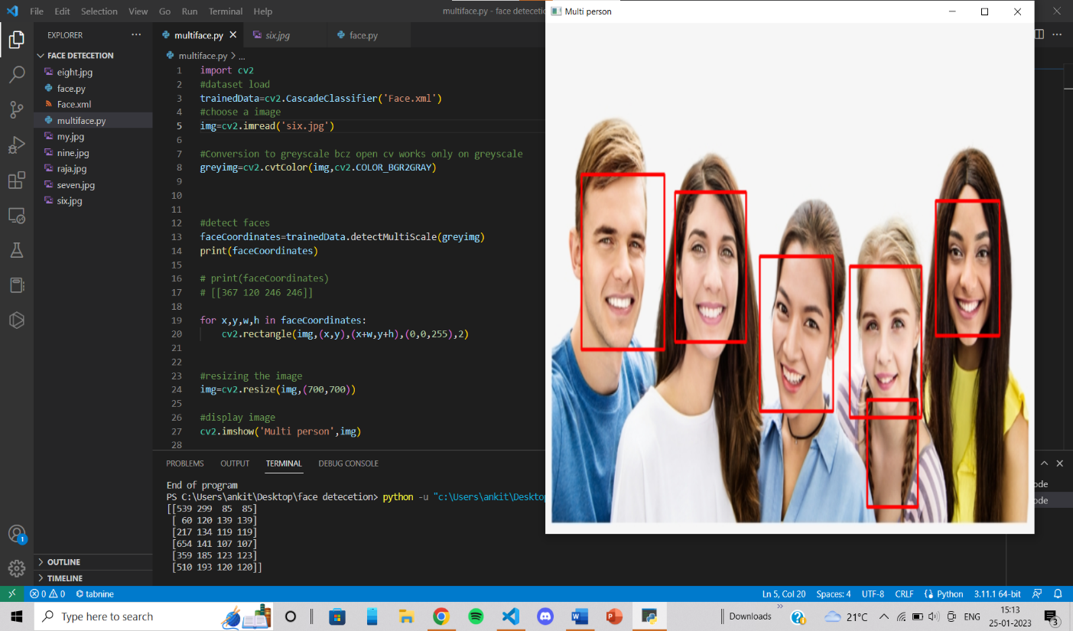

**CHAPTER**i**5**

**ConclusioniandiFutureiWork**

**Conclusion:**

Basedionitheiresultsiobtainedifromirunningitheicodeioniaisampleiimage,itheifaceidetectionialgorithmiwasiableitoidetectimultipleifacesiinitheiimage.iTheioutputifromitheifaceCoordinatesivariableidisplayeditheicoordinatesiofitheidetectedifaces.iHowever,itheiperformanceiofitheialgorithmiwillidependionitheiqualityiandiresolutioniofitheiimageiused,iasiwelliasitheiaccuracyiofitheipre-trainediclassifieriusediinitheicode.

Theilimitationsiofitheialgorithmishouldialsoibeidiscussed,isuchiasiitsipotentialidifficultyiinidetectingifacesiwithidifferentiskinitonesiorilightingiconditions.iTheialgorithmimayialsoihaveidifficultyidetectingifacesiininon-frontaliposesioripartialifaces.

Overall,itheiprovidedicodeiisiaibasiciimplementationiofitheiViola-JonesimethodiforifaceidetectioniusingitheiOpenCVilibrary.iWhileitheicodeidemonstrateditheiabilityitoidetectimultipleifacesiiniaisingleiimage,iitiisiimportantitoinoteithatitheiperformanceiofithisialgorithmicanibeiimprovediwithiailargeridatasetitoitrainitheiclassifier,iandiincorporatingiotheritechniquesisuchiasideepilearning.iFutureiworkishouldifocusioniimprovingitheiaccuracyiandirobustnessiofitheialgorithm.

**FutureiWork:**

Thereiareiseveralipotentialifutureimethodsiandinewisolutionsiinifaceidetectionithatiareicurrentlyibeingiresearchediandideveloped.iSomeiofitheseiinclude:

1. 3DiFaceiDetection:iInsteadiofidetectingifacesiini2Diimages,i3Difaceidetectioniaimsitoidetectifacesiini3Didataisuchiasipointicloudsioridepthimaps.iThisiapproachicaniimproveitheirobustnessiofifaceidetectionitoivariationsiinilightingiandipose,iasiwelliasihandleiocclusions.
2. Multi-modaliFaceiDetection:iMulti-modalifaceidetectioniaimsitoidetectifacesiusingimultipleimodalities,isuchiasiinfrarediandivisibleilight,itoiimproveitheirobustnessiofifaceidetectionitoivariationsiinilightingiconditions.
3. AdversarialiTraining:iAdversarialitrainingiaimsitoiimproveitheirobustnessiofifaceidetectionimodelsitoiadversarialiexamplesibyitrainingitheimodelioniaidatasetiofiadversarialiexamples.
4. ExplainableiAI:iWithitheiincreasingiuseiofideepilearningitechniquesiinifaceidetection,iExplainableiAIiisibecomingianiimportantiresearchiarea,ifocusingionidevelopingimethodsiforiunderstandingiandiinterpretingitheidecisionsimadeibyideepilearningimodels,iandimakingithemimoreitransparent.
5. FederatediLearning:iFederatedilearningiisiaidistributedimachineilearningitechniqueithatiallowsimultipleipartiesitoitrainiaimachineilearningimodeliwithoutisharingidata,iiticanibeiusefuliinifaceidetectioniwhenimultipleipartiesiwantitoitrainiaimodelibutidon'tiwantitoishareitheiridata.
6. Low-poweriandiedge-basedifaceidetection:iWithitheiincreasingiuseiofiedgeidevicesisuchiasiIoT,ilow-poweriandiedge-basedifaceidetectionimethodsiareibecomingimoreiimportant.iTheseimethodsiaimitoireduceitheicomputationalicomplexityiofifaceidetectionimodels,imakingithemisuitableiforiuseionilow-poweridevices.
7. IncorporatingimoreiadvanceditechniquesisuchiasiGenerativeiAdversarialiNetworksi(GANs)ioriVariationaliAutoencoderi(VAE)iforifaceidetection.
8. Incorporatingiactiveilearningitechniquesitoiimproveitheiperformanceiofifaceidetectionimodelsibyiselectingitheimostiinformativeisamplesiforiannotation.
9. Developingimethodsiforidealingiwithilarge-scaleidatasets,isuchiasiactiveilearning,itransferilearning,iandifederatedilearning.

I

**iiiiiiiiiiiiiiiiiiiiiiiiiiiiiiiiiiiiiiREFERENCES**

1. [www.analyticsvidhya.com](http://www.analyticsvidhya.com)
2. <https://opencv.org/>
3. <https://www.tensorflow.org/>
4. <https://chat.openai.com/chat>